**Final Year B. Tech., Sem VII 2022-23**

**Cryptography And Network Security**

**PRN/ Roll No: 2020BTECS00206**

**Full Name: SAYALI YOGESH DESAI**

**Batch: B4**

**Assignment No. 6**

1. **Aim:**

To encrypt given plain text using the DES algorithm

1. **Theory:**

The Data Encryption Standard (DES) is a symmetric-key block cipher published by the National Institute of Standards and Technology (NIST).

DES is an implementation of a Feistel Cipher. It uses 16 round Feistel structure. The block size is 64-bit. Though, key length is 64-bit, DES has an effective key length of 56 bits, since 8 of the 64 bits of the key are not used by the encryption algorithm (function as check bits only). General Structure of DES is depicted in the following illustration –

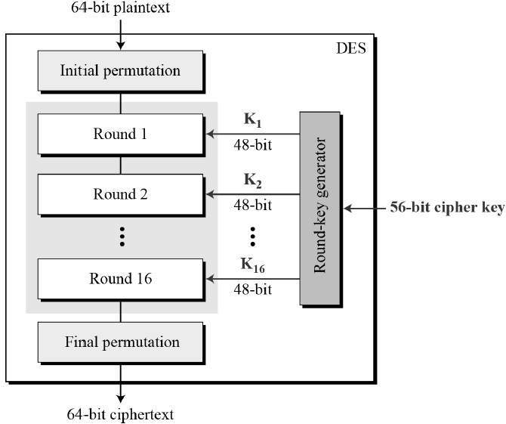

Since DES is based on the Feistel Cipher, all that is required to specify DES is −

* Round function
* Key schedule
* Any additional processing − Initial and final permutation

Initial and Final Permutation

The initial and final permutations are straight Permutation boxes (P-boxes) that are inverses of each other. They have no cryptography significance in DES. The initial and final permutations are shown as follows −

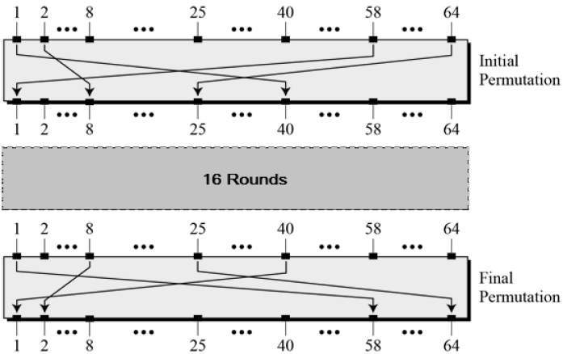

## Round Function

The heart of this cipher is the DES function, *f*. The DES function applies a 48-bit key to the rightmost 32 bits to produce a 32-bit output.

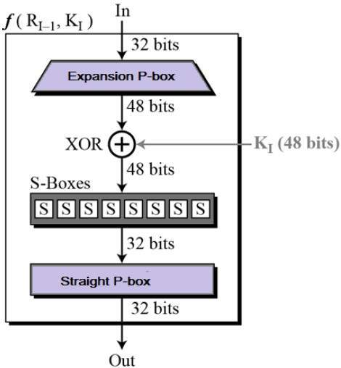

**Expansion Permutation Box** − Since right input is 32-bit and round key is a 48-bit, we first need to expand right input to 48 bits. Permutation logic is graphically depicted in the following illustration −

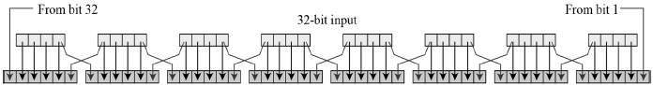

The graphically depicted permutation logic is generally described as table in DES specification illustrated as shown −

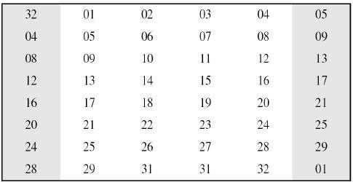

**XOR (Whitener).** − After the expansion permutation, DES does XOR operation on the expanded right section and the round key. The round key is used only in this operation.

**Substitution Boxes.** − The S-boxes carry out the real mixing (confusion). DES uses 8 S-boxes, each with a 6-bit input and a 4-bit output. Refer the following illustration −

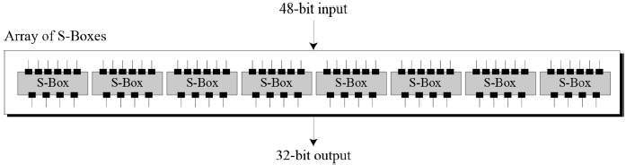

The S-box rule is illustrated below −

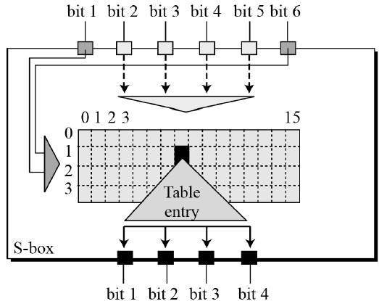

There are a total of eight S-box tables. The output of all eight s-boxes is then combined in to 32 bit section.

**Straight Permutation** − The 32 bit output of S-boxes is then subjected to the straight permutation with rule shown in the following illustration:

## Straight Permutation

## Key Generation

The round-key generator creates sixteen 48-bit keys out of a 56-bit cipher key. The process of key generation is depicted in the following illustration −

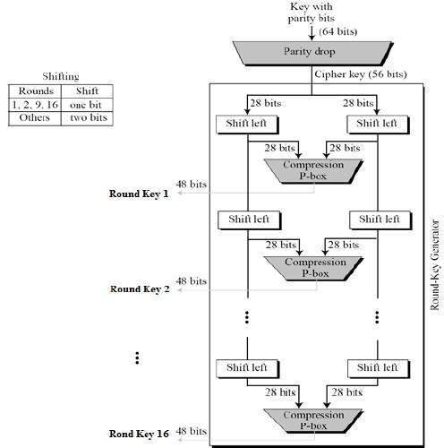

The logic for Parity drop, shifting, and Compression P-box is given in the DES description.

1. **Code:**

#include <bits/stdc++.h>

using namespace std;

string hexToBin(string s) {

unordered_map<char, string> mp;

mp['0'] = "0000";

mp['1'] = "0001";

mp['2'] = "0010";

mp['3'] = "0011";

mp['4'] = "0100";

mp['5'] = "0101";

mp['6'] = "0110";

mp['7'] = "0111";

mp['8'] = "1000";

mp['9'] = "1001";

mp['A'] = "1010";

mp['B'] = "1011";

mp['C'] = "1100";

mp['D'] = "1101";

mp['E'] = "1110";

mp['F'] = "1111";

stringstream bin;

for (int i = 0; i < s.size(); i++) {

bin << mp[s[i]];

}

return bin.str();

}

string binToHex(string s) {

unordered_map<string, string> mp;

mp["0000"] = "0";

mp["0001"] = "1";

mp["0010"] = "2";

mp["0011"] = "3";

mp["0100"] = "4";

mp["0101"] = "5";

mp["0110"] = "6";

mp["0111"] = "7";

mp["1000"] = "8";

mp["1001"] = "9";

mp["1010"] = "A";

mp["1011"] = "B";

mp["1100"] = "C";

mp["1101"] = "D";

mp["1110"] = "E";

mp["1111"] = "F";

stringstream hex;

for (int i = 0; i < s.length(); i += 4) {

string ch = s.substr(i, 4);

hex << mp[ch];

}

return hex.str();

}

string permute(string k, int *arr, int n) {

stringstream per;

for (int i = 0; i < n; i++) {

per << k[arr[i] - 1];

}

return per.str();

}

string shiftLeft(string k, int shifts) {

string s = "";

for (int i = 0; i < shifts; i++) {

for (int j = 1; j < 28; j++) {

s += k[j];

}

s += k[0];

k = s;

s = "";

}

return k;

}

string XOR(string a, string b) {

stringstream ans;

for (int i = 0; i < a.size(); i++) {

if (a[i] == b[i]) {

ans << "0";

} else {

ans << "1";

}

}

return ans.str();

}

string encrypt(string plain, vector<string> rkb, vector<string> rk) {

// Hexadecimal to binary

plain = hexToBin(plain);

// Initial Permutation Table

int initial_perm[64] = {58, 50, 42, 34, 26, 18, 10, 2,

60, 52, 44, 36, 28, 20, 12, 4,

62, 54, 46, 38, 30, 22, 14, 6,

64, 56, 48, 40, 32, 24, 16, 8,

57, 49, 41, 33, 25, 17, 9, 1,

59, 51, 43, 35, 27, 19, 11, 3,

61, 53, 45, 37, 29, 21, 13, 5,

63, 55, 47, 39, 31, 23, 15, 7

};

// Initial Permutation

plain = permute(plain, initial_perm, 64);

cout << "After initial permutation: " << binToHex(plain) << endl;

// Splitting

string left = plain.substr(0, 32);

string right = plain.substr(32, 32);

cout << "After splitting: L0=" << binToHex(left)

<< " R0=" << binToHex(right) << endl;

// Expansion D-box Table

int exp_d[48] = {32, 1, 2, 3, 4, 5, 4, 5,

6, 7, 8, 9, 8, 9, 10, 11,

12, 13, 12, 13, 14, 15, 16, 17,

16, 17, 18, 19, 20, 21, 20, 21,

22, 23, 24, 25, 24, 25, 26, 27,

28, 29, 28, 29, 30, 31, 32, 1

};

// S-box Table

int s[8][4][16] = {{

14, 4, 13, 1, 2, 15, 11, 8, 3, 10, 6, 12, 5, 9, 0, 7,

0, 15, 7, 4, 14, 2, 13, 1, 10, 6, 12, 11, 9, 5, 3, 8,

4, 1, 14, 8, 13, 6, 2, 11, 15, 12, 9, 7, 3, 10, 5, 0,

15, 12, 8, 2, 4, 9, 1, 7, 5, 11, 3, 14, 10, 0, 6, 13

},

{ 15, 1, 8, 14, 6, 11, 3, 4, 9, 7, 2, 13, 12, 0, 5, 10,

3, 13, 4, 7, 15, 2, 8, 14, 12, 0, 1, 10, 6, 9, 11, 5,

0, 14, 7, 11, 10, 4, 13, 1, 5, 8, 12, 6, 9, 3, 2, 15,

13, 8, 10, 1, 3, 15, 4, 2, 11, 6, 7, 12, 0, 5, 14, 9

},

{ 10, 0, 9, 14, 6, 3, 15, 5, 1, 13, 12, 7, 11, 4, 2, 8,

13, 7, 0, 9, 3, 4, 6, 10, 2, 8, 5, 14, 12, 11, 15, 1,

13, 6, 4, 9, 8, 15, 3, 0, 11, 1, 2, 12, 5, 10, 14, 7,

1, 10, 13, 0, 6, 9, 8, 7, 4, 15, 14, 3, 11, 5, 2, 12

},

{ 7, 13, 14, 3, 0, 6, 9, 10, 1, 2, 8, 5, 11, 12, 4, 15,

13, 8, 11, 5, 6, 15, 0, 3, 4, 7, 2, 12, 1, 10, 14, 9,

10, 6, 9, 0, 12, 11, 7, 13, 15, 1, 3, 14, 5, 2, 8, 4,

3, 15, 0, 6, 10, 1, 13, 8, 9, 4, 5, 11, 12, 7, 2, 14

},

{ 2, 12, 4, 1, 7, 10, 11, 6, 8, 5, 3, 15, 13, 0, 14, 9,

14, 11, 2, 12, 4, 7, 13, 1, 5, 0, 15, 10, 3, 9, 8, 6,

4, 2, 1, 11, 10, 13, 7, 8, 15, 9, 12, 5, 6, 3, 0, 14,

11, 8, 12, 7, 1, 14, 2, 13, 6, 15, 0, 9, 10, 4, 5, 3

},

{ 12, 1, 10, 15, 9, 2, 6, 8, 0, 13, 3, 4, 14, 7, 5, 11,

10, 15, 4, 2, 7, 12, 9, 5, 6, 1, 13, 14, 0, 11, 3, 8,

9, 14, 15, 5, 2, 8, 12, 3, 7, 0, 4, 10, 1, 13, 11, 6,

4, 3, 2, 12, 9, 5, 15, 10, 11, 14, 1, 7, 6, 0, 8, 13

},

{ 4, 11, 2, 14, 15, 0, 8, 13, 3, 12, 9, 7, 5, 10, 6, 1,

13, 0, 11, 7, 4, 9, 1, 10, 14, 3, 5, 12, 2, 15, 8, 6,

1, 4, 11, 13, 12, 3, 7, 14, 10, 15, 6, 8, 0, 5, 9, 2,

6, 11, 13, 8, 1, 4, 10, 7, 9, 5, 0, 15, 14, 2, 3, 12

},

{ 13, 2, 8, 4, 6, 15, 11, 1, 10, 9, 3, 14, 5, 0, 12, 7,

1, 15, 13, 8, 10, 3, 7, 4, 12, 5, 6, 11, 0, 14, 9, 2,

7, 11, 4, 1, 9, 12, 14, 2, 0, 6, 10, 13, 15, 3, 5, 8,

2, 1, 14, 7, 4, 10, 8, 13, 15, 12, 9, 0, 3, 5, 6, 11

}

};

// Straight Permutation Table

int per[32] = {16, 7, 20, 21,

29, 12, 28, 17,

1, 15, 23, 26,

5, 18, 31, 10,

2, 8, 24, 14,

32, 27, 3, 9,

19, 13, 30, 6,

22, 11, 4, 25

};

cout << endl;

for (int i = 0; i < 16; i++) {

// Expansion D-box

string right_expanded = permute(right, exp_d, 48);

// XOR RoundKey[i] and right_expanded

string x = XOR(rkb[i], right_expanded);

// S-boxes

string op = "";

for (int i = 0; i < 8; i++) {

int row = 2 * int(x[i * 6] - '0') + int(x[i * 6 + 5] - '0');

int col = 8 * int(x[i * 6 + 1] - '0') + 4 * int(x[i * 6 + 2] - '0') + 2 * int(x[i * 6 + 3] - '0') + int(x[i * 6 + 4] - '0');

int val = s[i][row][col];

op += char(val / 8 + '0');

val = val % 8;

op += char(val / 4 + '0');

val = val % 4;

op += char(val / 2 + '0');

val = val % 2;

op += char(val + '0');

}

// Straight D-box

op = permute(op, per, 32);

// XOR left and op

x = XOR(op, left);

left = x;

// Swapper

if (i != 15) {

swap(left, right);

}

cout << "Round " << i + 1 << " " << binToHex(left) << " "

<< binToHex(right) << " " << rk[i] << endl;

}

// Combination

string combine = left + right;

// Final Permutation Table

int final_perm[64] = {40, 8, 48, 16, 56, 24, 64, 32,

39, 7, 47, 15, 55, 23, 63, 31,

38, 6, 46, 14, 54, 22, 62, 30,

37, 5, 45, 13, 53, 21, 61, 29,

36, 4, 44, 12, 52, 20, 60, 28,

35, 3, 43, 11, 51, 19, 59, 27,

34, 2, 42, 10, 50, 18, 58, 26,

33, 1, 41, 9, 49, 17, 57, 25

};

// Final Permutation

string cipher = binToHex(permute(combine, final_perm, 64));

return cipher;

}

int main() {

string plain, key;

// plain = "This is a test text";

// key = "this is a test";

// Key Generation

cout << "Enter the plain text: ";

getline(cin, plain);

cout << "Enter the key: ";

getline(cin, key);

// Hex to binary

key = hexToBin(key);

// Parity bit drop table

int keyp[56] = {57, 49, 41, 33, 25, 17, 9,

1, 58, 50, 42, 34, 26, 18,

10, 2, 59, 51, 43, 35, 27,

19, 11, 3, 60, 52, 44, 36,

63, 55, 47, 39, 31, 23, 15,

7, 62, 54, 46, 38, 30, 22,

14, 6, 61, 53, 45, 37, 29,

21, 13, 5, 28, 20, 12, 4

};

// getting 56 bit key from 64 bit using the parity bits

key = permute(key, keyp, 56); // key without parity

// Number of bit shifts

int shift_table[16] = {1, 1, 2, 2,

2, 2, 2, 2,

1, 2, 2, 2,

2, 2, 2, 1

};

// Key- Compression Table

int key_comp[48] = {14, 17, 11, 24, 1, 5,

3, 28, 15, 6, 21, 10,

23, 19, 12, 4, 26, 8,

16, 7, 27, 20, 13, 2,

41, 52, 31, 37, 47, 55,

30, 40, 51, 45, 33, 48,

44, 49, 39, 56, 34, 53,

46, 42, 50, 36, 29, 32

};

// Splitting

string left = key.substr(0, 28);

string right = key.substr(28, 28);

vector<string> rkb; // rkb for RoundKeys in binary

vector<string> rk; // rk for RoundKeys in hexadecimal

for (int i = 0; i < 16; i++) {

// Shifting

left = shiftLeft(left, shift_table[i]);

right = shiftLeft(right, shift_table[i]);

// Combining

string combine = left + right;

// Key Compression

string RoundKey = permute(combine, key_comp, 48);

rkb.push_back(RoundKey);

rk.push_back(binToHex(RoundKey));

}

cout << "\nEncryption:\n\n";

string cipher = encrypt(plain, rkb, rk);

cout << "\nCipher Text: " << cipher << endl;

cout << "\nDecryption\n\n";

reverse(rkb.begin(), rkb.end());

reverse(rk.begin(), rk.end());

string text = encrypt(cipher, rkb, rk);

cout << "\nPlain Text: " << text << endl;

}

1. **Output:**

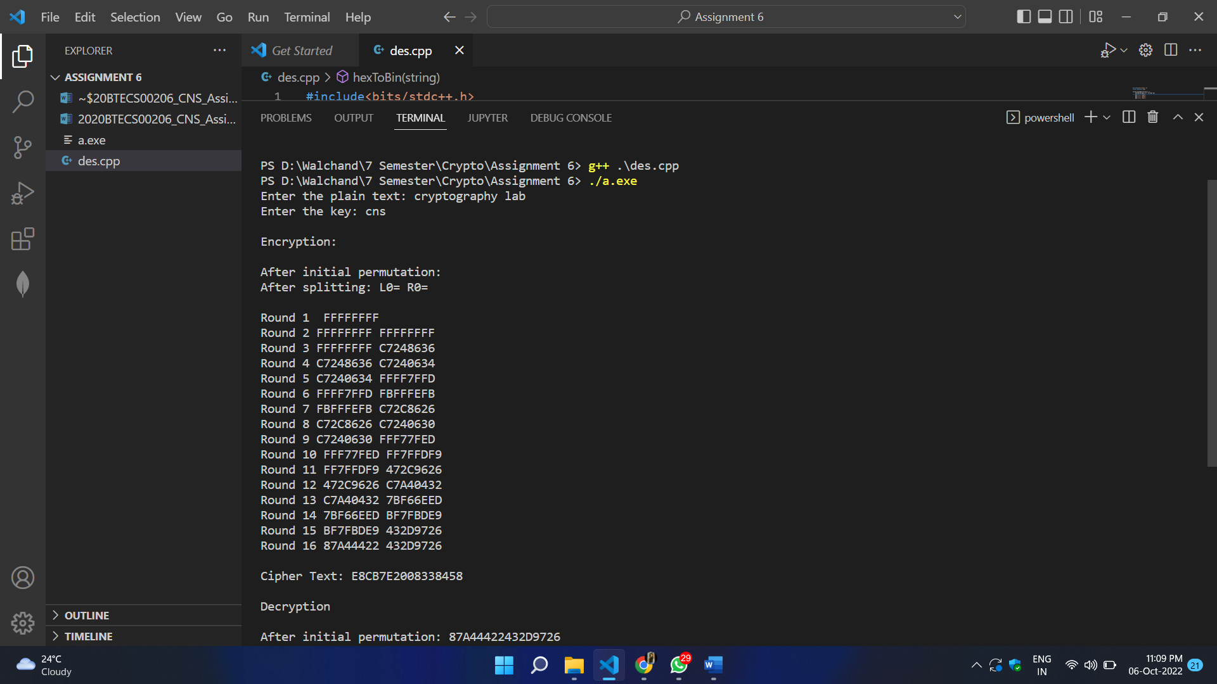

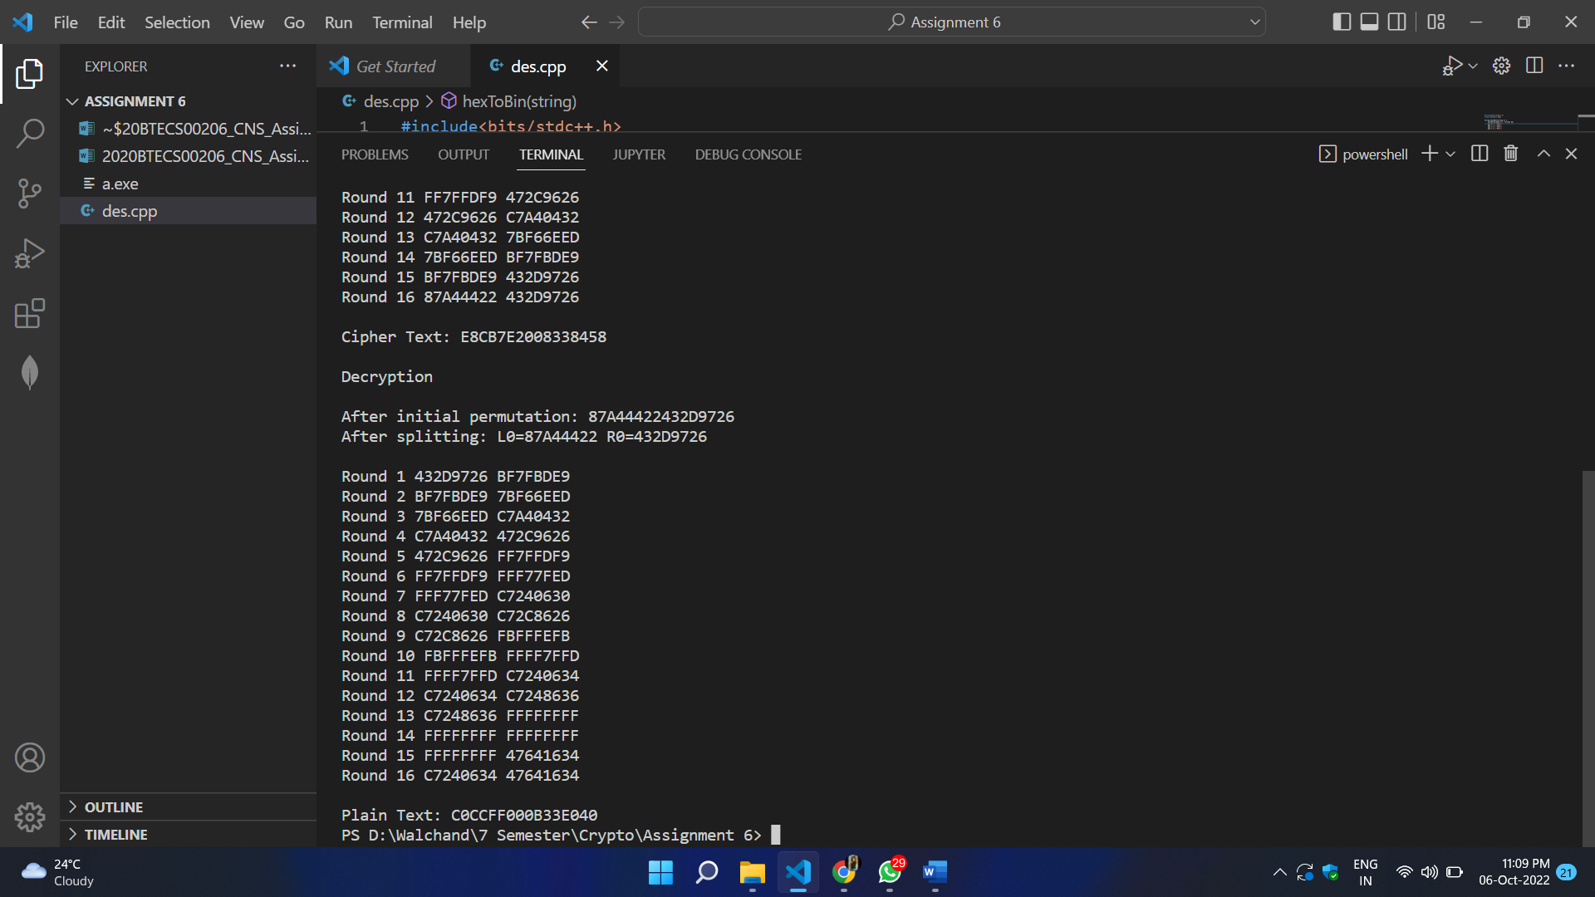

1. **Conclusion:**

Successfully encrypted the given plain text using DES Algorithm.